**Deploy Springboot Application using AWS Ec2 instances**

**Step 1: First need to search EC2**

**Step 2: Click on Launch Instance**  
  
**

**Step 4: Select Amazon Linux aws**

**Step 5: Instance Type – t3.micro And key-pair as bydefault we have to select or create new one.**

Create security group and select Allow SSH traffic from

**Step 6: Storage – 8GiB by default and then click on Launch Instance**

**Step 7: After creating Instance, need to click on (i-09d7c50e3250d924a) link**

**Step 8: Now Instance state is Running state…Then click on Connect button.**

**Step 9: Copied the command….**

**Step 10: Go into .pem file location where it is available**

**Step 11: On the same place, click on gitbash and paste the command from Aws and asking permission as yes.**

**Step 12: Check git is installed or not**  
**If git is not Installed then use command like - sudo yum install git -y**

**Step 13: Check Maven is installed or not**   
**If Maven is not installed then use command like - sudo yum install maven -y**  
  
**Step 14: Check any instance available in AWS, we are getting 0. Then clone the project from github**  
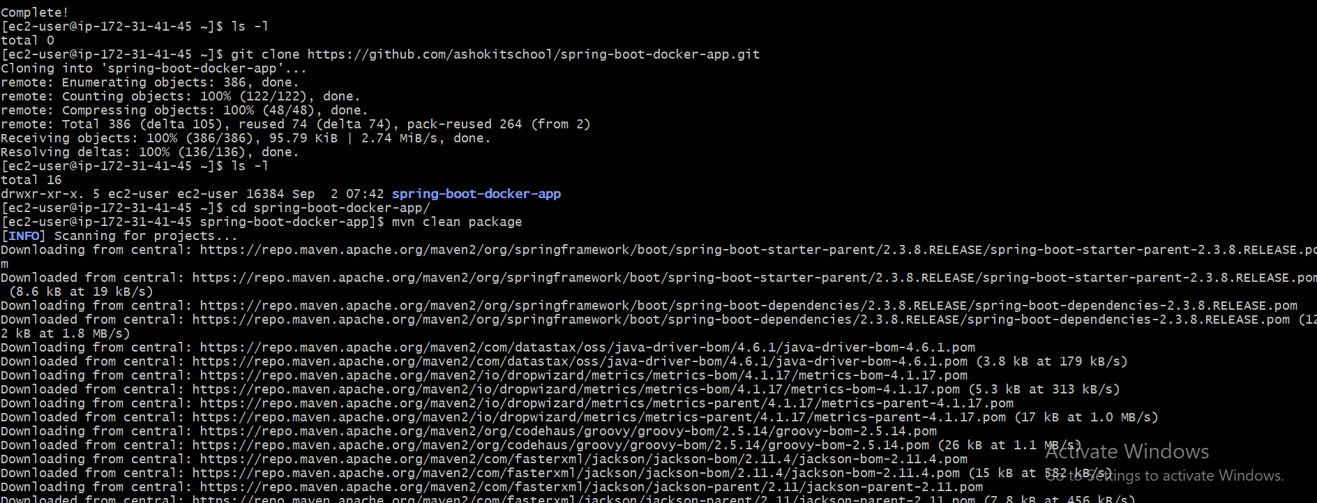

**Command: git clone** [**https://github.com/ashokitschool/spring-boot-docker-app.git**](https://github.com/ashokitschool/spring-boot-docker-app.git)

**Step 15: Check project name by using command: ls -l**  


**Step 16: Go to Project using cd command**

**Step 17: Now Maven cleaning package - command: mvn clean package**

**Step 18: Check jar by command then Run jar file.**  
**Command: - ls -l target And java -jar target/spring-boot-docker-app.jar**  
  
**Step 19: Finally Enable Embedded server port 8080 in security group Inbound rules.  
Click on Ec2 🡪 Instances(running)**

**Step 20: Select that machine i.e. App-VM-Server-Raj And go to Security tabs**

**Step 21: In Security, click on security groups link**

**Step 22: Click on Edit Inbound rules.**

**Step 23: Now Click on Add rule**

**Step 24: Set Port range :- 8080 and Source :- Anywhere-IPv4 then click on Save rules button**

**Step 25: Now go to our machine i.e. App-VM-Server-Raj and then copied the public IPv4 address i.e. 13.61.175.171 for accessing application**

**Step 26: Go to browser and check IPv4 address with port number 8080.**

**Finally, Got the proper result as expected.**